India Temples Data Generated from Python Program

Purpose : Generating the India’s Famous Temples data from Google for Data Analytics

Developed by GCP Guild Members, Kyndryl.

Date : June 8, 2022

Pre requirements

Follow this document for installation of the required modules

[Check the required modules.docx](https://kyndryl.sharepoint.com/:w:/r/sites/GoogleAllianceCommunity/Shared%20Documents/General/Google%20Connect/Check%20the%20required%20modules.docx?d=w708ce06dd29d4d2e8547528244db51ed&csf=1&web=1&e=6e3LuD)

check module

[checkmodule.py](https://kyndryl.sharepoint.com/:u:/r/sites/GoogleAllianceCommunity/Shared%20Documents/General/Google%20Connect/checkmodule.py?csf=1&web=1&e=KFaKh8)

python checkmodule.py

this utility to help to install required modules

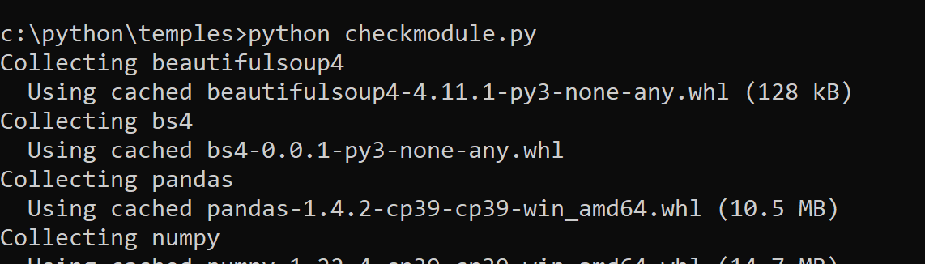

otherwise, you can also use below commands to install

pip3 install pandas

pip3 install numpy

pip3 install beautifulsoup4

pip install jupyterlab

Download from Kyndryl Share point

[googledata.py](https://kyndryl.sharepoint.com/:u:/r/sites/GoogleAllianceCommunity/Shared%20Documents/General/Google%20Connect/googledata.py?csf=1&web=1&e=i9ar0C)

[Temple Data Generation](https://kyndryl.sharepoint.com/:f:/r/sites/GoogleAllianceCommunity/Shared%20Documents/GCP%20Guild%20Use%20Cases/Googling%20Data%20Sheet%20-%20Python/Python%20for%20Google/Temple%20Data%20Generation?csf=1&web=1&e=dyl7vV)

[templesview.py](https://kyndryl.sharepoint.com/:u:/r/sites/GoogleAllianceCommunity/Shared%20Documents/General/Google%20Connect/templesview.py?csf=1&web=1&e=ISFhgw)

[Temples.ipynb](https://kyndryl.sharepoint.com/:u:/r/sites/GoogleAllianceCommunity/Shared%20Documents/General/Google%20Connect/Temples.ipynb?csf=1&web=1&e=O8943P)

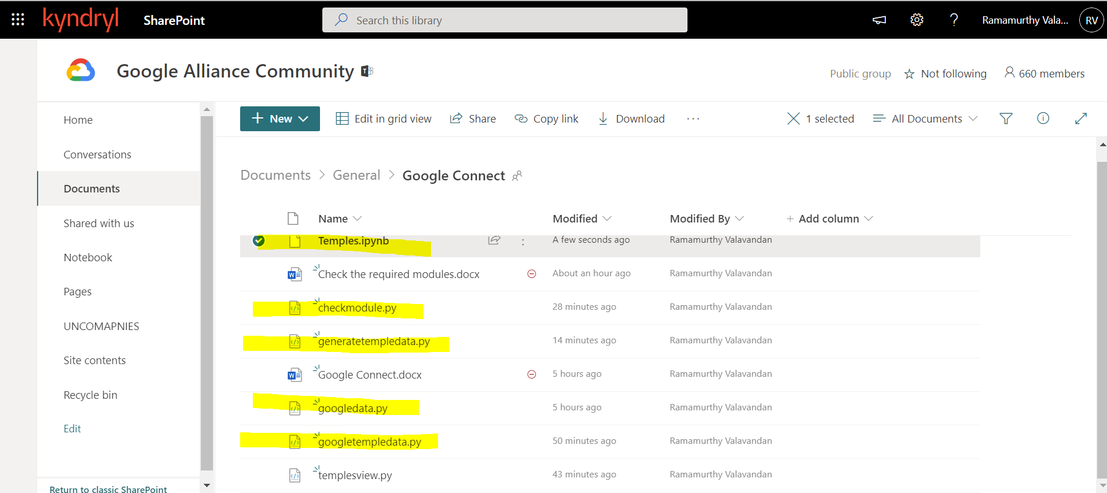

Save the program in C:\python\temples

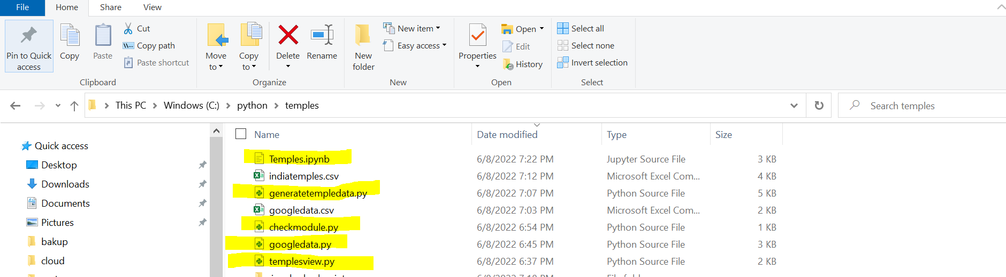

Execute the program :

python googledata.py <http://www.walkthroughindia.com/hindu-temple/top-25-popular-hindu-temples-tamil-nadu/>

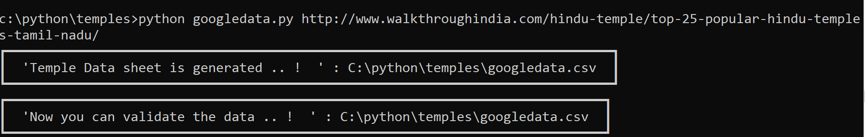

Result



python generatetempledata.py



Result

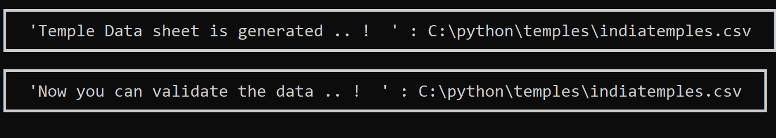

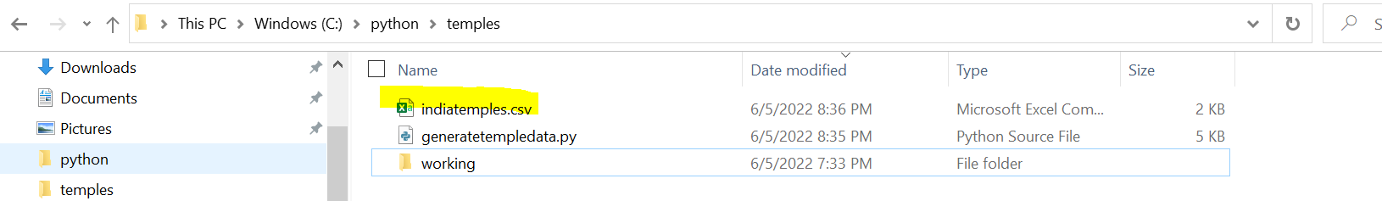

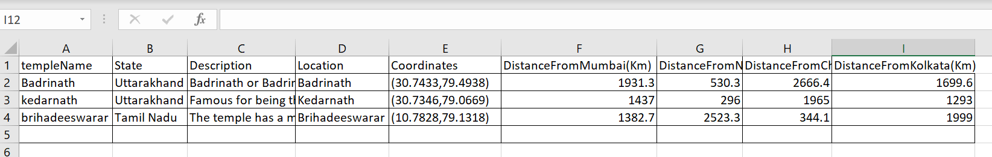

|  |  |  |  |  |  |  |  |  |
| --- | --- | --- | --- | --- | --- | --- | --- | --- |
| templeName | State | Description | Location | Coordinates | DistanceFromMumbai(Km) | DistanceFromNewDelhi(Km) | DistanceFromChennai(Km) | DistanceFromKolkata(Km) |

Either you can try python templesview.py

Or

cd C:\python\temples

jupyter-lab

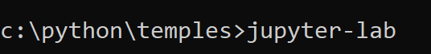

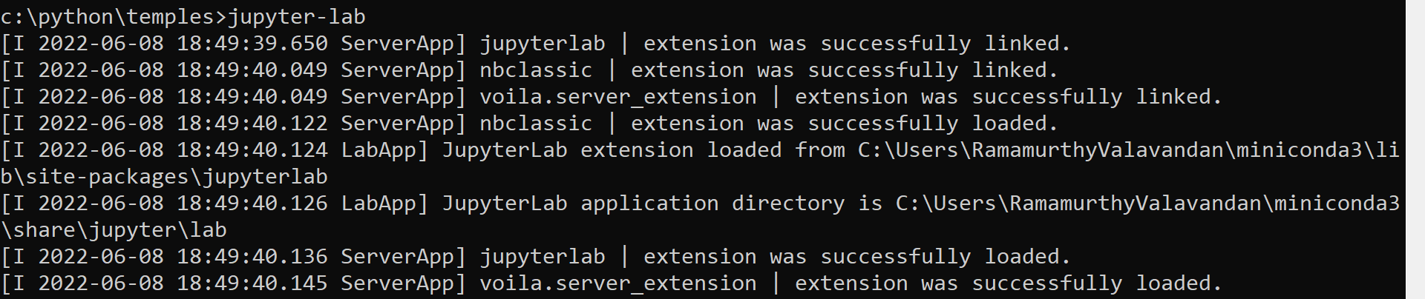

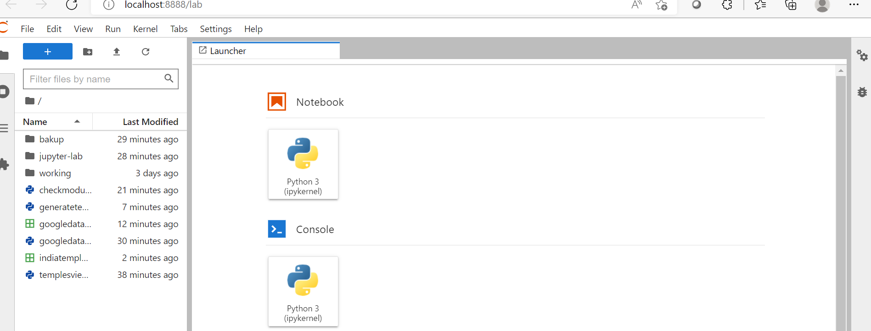

Click python3 (ipykernel)

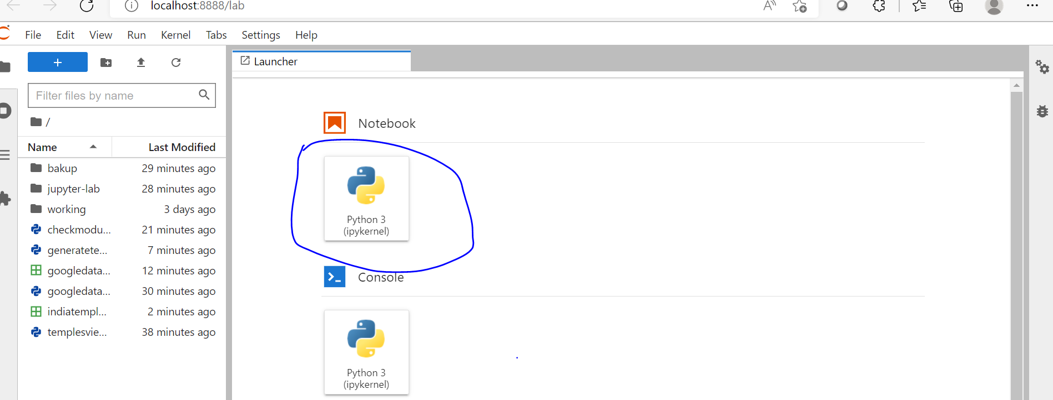

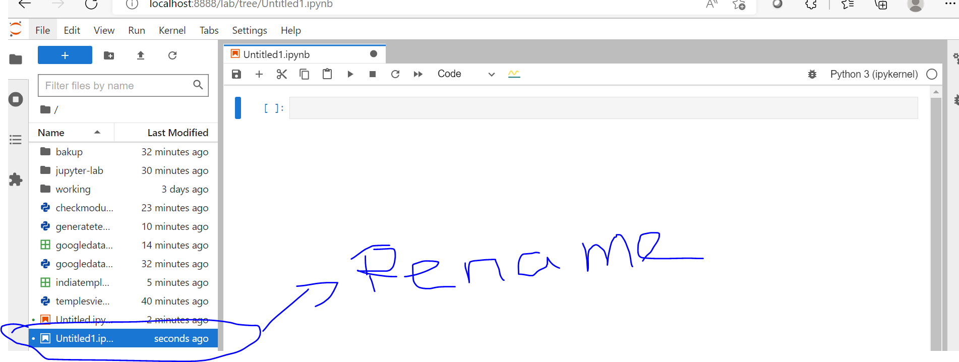

Right click and rename ‘temples.ipynp’

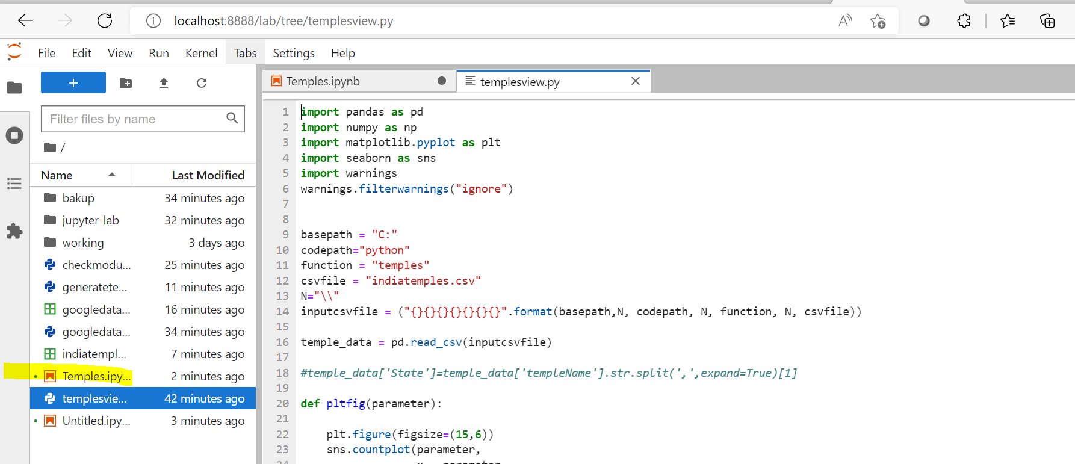

Click voila

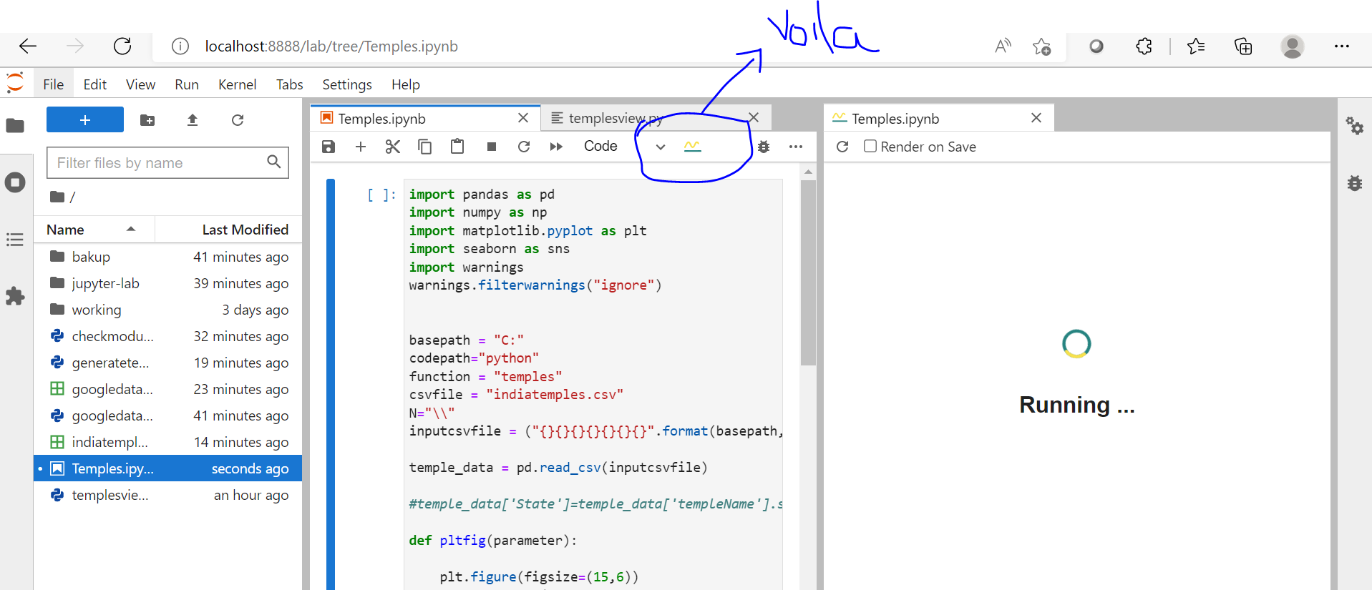

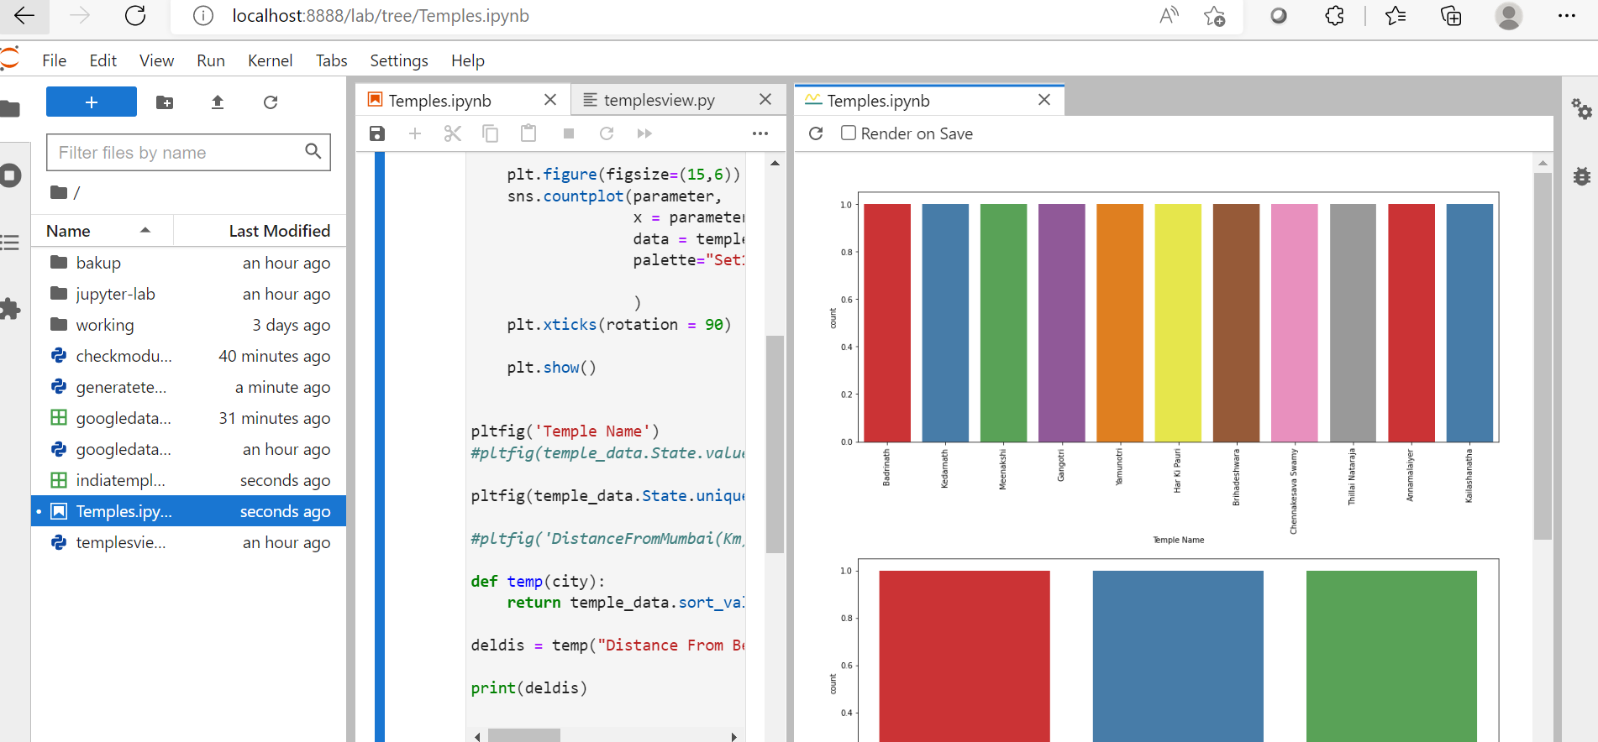

Appendix

Help documents

[Google Connect.docx](https://kyndryl.sharepoint.com/:w:/r/sites/GoogleAllianceCommunity/Shared%20Documents/General/Google%20Connect/Google%20Connect.docx?d=w1eb2fa414e9243c6a4fc1734b40c307c&csf=1&web=1&e=WuYNAV)

<https://kyndryl.sharepoint.com/:w:/r/sites/GoogleAllianceCommunity/Shared%20Documents/General/Google%20Connect/Google%20Connect.docx?d=w1eb2fa414e9243c6a4fc1734b40c307c&csf=1&web=1&e=WuYNAV>

[Check the required modules.docx](https://kyndryl.sharepoint.com/:w:/r/sites/GoogleAllianceCommunity/Shared%20Documents/General/Google%20Connect/Check%20the%20required%20modules.docx?d=w708ce06dd29d4d2e8547528244db51ed&csf=1&web=1&e=6e3LuD)

<https://kyndryl.sharepoint.com/:w:/r/sites/GoogleAllianceCommunity/Shared%20Documents/General/Google%20Connect/Check%20the%20required%20modules.docx?d=w708ce06dd29d4d2e8547528244db51ed&csf=1&web=1&e=6e3LuD>